Angular in section 7,9, 10, 11

Program.cs method main() is ofcourse the starting point.

In there we call a method called CreateHostBuilder() which calls CreateDefaultBuilder().

**CreateDefaultBuilder() -**

gives us a new instance of hostBuilder with preconfigured defaults

It will set ContectRootPath. Which is path of our project.

It will load Configuration environment info from **environment variables**  and **appsettings.json,**

**Appsettings.[enviromentName].json.**  And command line arguments ETC.

Also it points us for what else to use while starting up the project

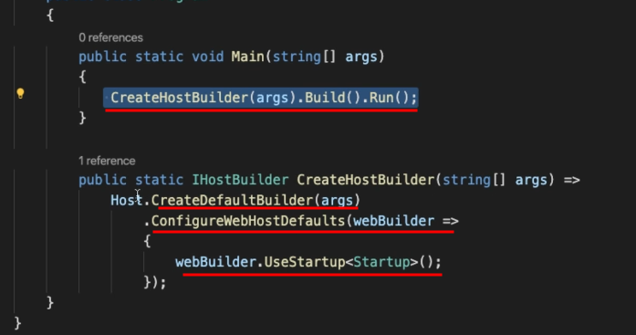

In startup class in contructor we inject the configuration

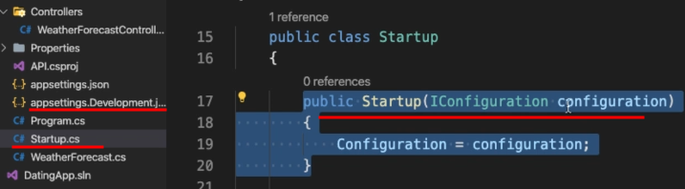

**The ConfigureService() -**

This method is a dependency injector container.

If we want to make a class or service available to other parts of application. Then we add it here.

And dotnet core will take care of creation and destruction these dependencies.

**Configure()-**

and this is used to configure the HTTP request pipeline as we

made our guest request from our browser to our controller endpoint.

Then our request goes through a series of middleware on the way in and also on the way out.

Ordering of these layers is imp here

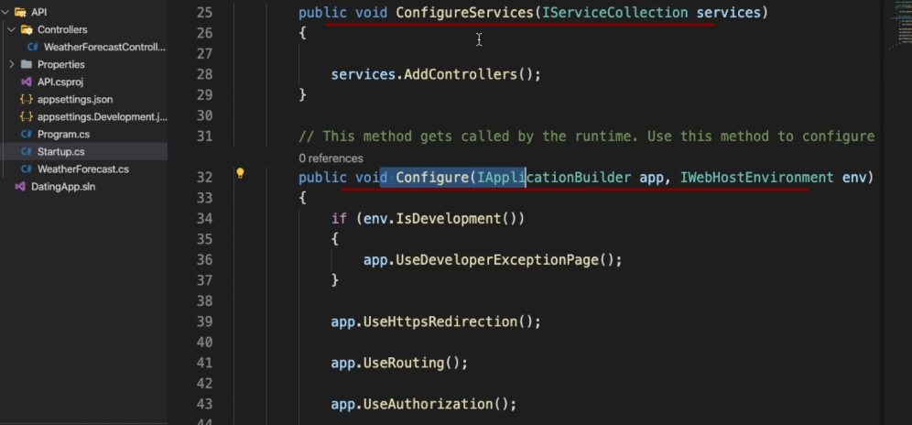

Launchsettings.json inside properties folder is used while running this application.

Creating Entities – physical things in out app here AppUsers

While creating props of classes (entities) make sure we use PascalCasing. As we are using netcore.identity , entity framework there it uses to pascal casing.

**Entity Framework**

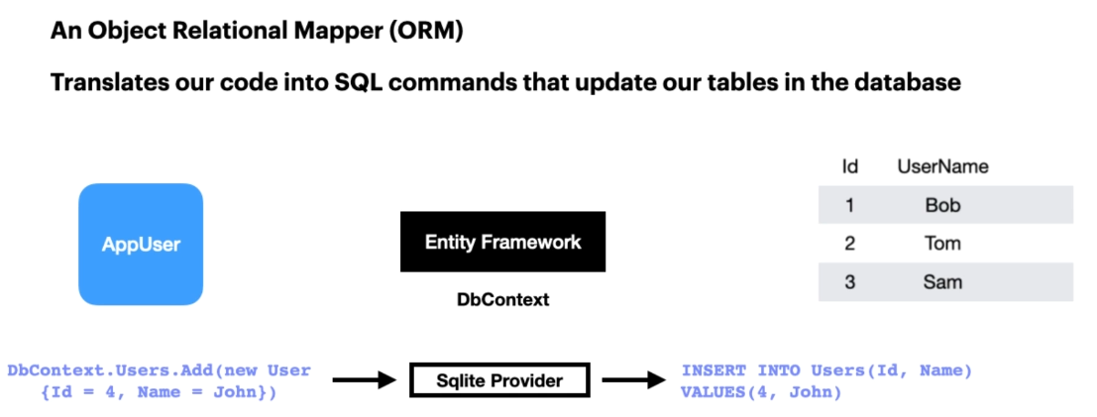

So what we have at the moment is an app user entity, just a simple class that we've created with an

ID property that's an integer and a string property for the user name.

What we're going to introduce is entity framework.

And when we add entity framework, we need to create an important class that derives from the DB context

class that we get with entity framework.

Now this class acts as a bridge between our domain or entity classes and the database.

And this DB context class is the primary class we use for interacting with our database.

Now, what entity framework does for us, if we just take a look at an example, is it allows us to

write something called link queries, which is what we see here on the left.

We say that we get our DB context DOT users, because when we add our user entity to our DB context

class, then we will have access to a property called Users, which represents our users table in our

database.

And then, for example, we could add a new user with an idea for and a name equal to John.

Now, Entity Framework works with database providers.

Now, the one that we're going to use purely for development is SQLite.

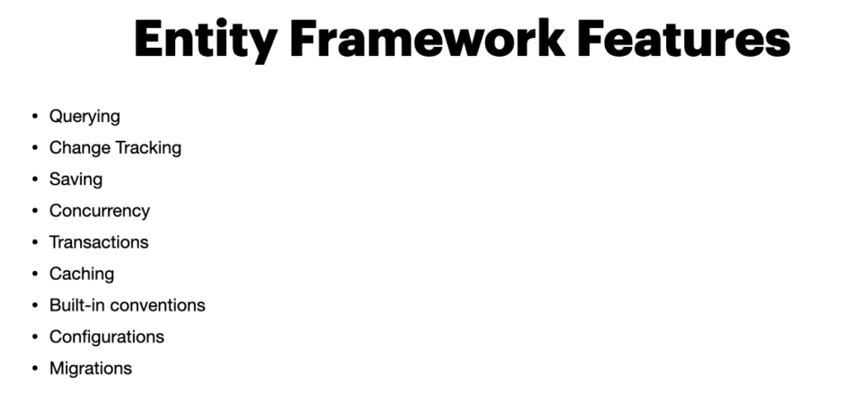

Tracking or keep track of its two framework will keep track of changes occurring in our entities which

need to be submitted to the database.

It also allows us to save the database and entity framework will execute insert updates and delete commands

to the database as the DB context class gives us a save changes method that we can use.

We'll see that very soon.

It also gives us concurrency.

It uses optimistic concurrency by default to protect overwriting changes made by another user, since

data was fetched from the database also deals with transactions and it provides automatic transaction

management whilst querying.

Or saving data.

It also includes first level cashing out of the box, so repeated querying will return data from the

cash instead of hitting the database.

It also offers built-In conventions.

And when I was talking about Whiley ID property needs to be named ID is because entity framework follows

conventions and includes a set of default rules which automatically configure the entity framework schema

or the model that we use to create our database.

We can also configure our entities and there's ways to configure these so that we can override the conventions

if we wish to do so.

And it also offers us migration's and we'll take a look at this soon.

But this gives us the ability to create a database schema so that when we start our application or we

run a particular command, we can automatically generate our database in our database server.

**Creating Database and adding entityFeramework to application**

EntityFrameworkCore.Sqlite this database proviveder is used.

As we install the package an entry will be added to the apiProj.cs for that project

Create a (DataContext)DbContext class which is bridge between database and code.

Data context class is inherited from DbContext class which is from entityFrameworkCore.

Create a contructor.

And create a Dbset for AppUser

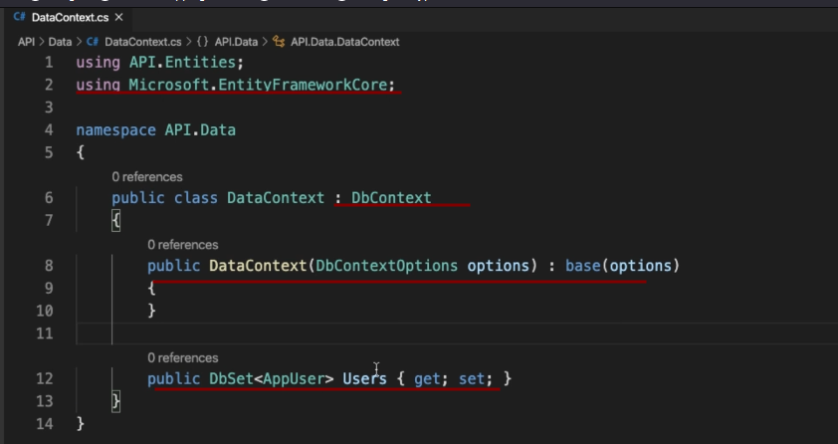

Then create connection string in appsettings.development.json. and use this configuration in startup class in contructor

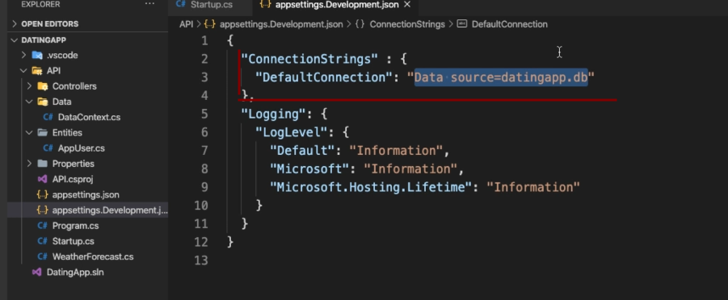

Now in startup ctor assign the config to local class variable

Then in configuration service method which is our dependency injector container add our DataContext class which is derrivred from Dbcontext

Code is as follows.

Use the connection string we mentioned in the appsetting.dev .

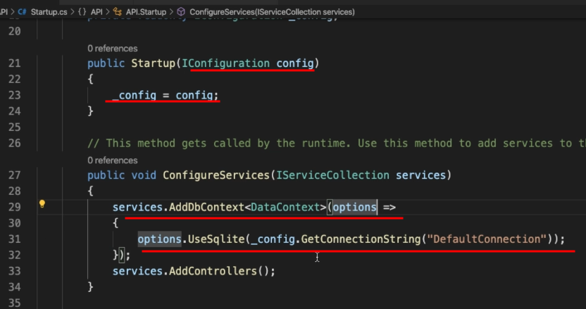

Download the tool dotnet-ef and then install it.

create a migration and the migration is going to take a look at

our classes and create a database schema or the code to create a database based on our code that we've

written so far.

Use below command. This requires entityFrameworkcore.design. get it first then run the command to create migrations

Make sure to give -o option in the command to mention specific folder to create the migrations

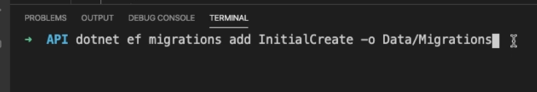

Output of the command , initial create class is imp for us.

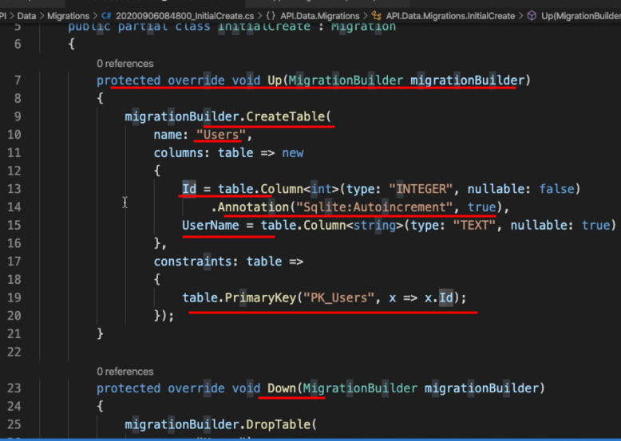

When we run the command to update our database, it's going to create a table called users.

It's going to have two columns, the ID column and the user name column.

The ID column is going to be an integer.

And because it's called ID, this is also our primary key for this table.

And it's also going to auto increment this every time a new record is created as well.

And all of this is taking place by convention.

We didn't need to tell entity framework that the ID was our primary key.

Conventionally, it knows that anything called an ID, unless we tell it otherwise, should be our primary

key.

Down method simply deletes the table

To create database use this command

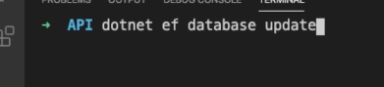

Now use any sql data explorer to view and query our databases

**Creatnig Controller**

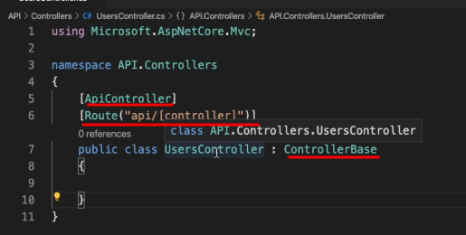

to make class a controller it has to be derived from **ControllerBase**

an attribute called ApiController has to be applied

another is route() here in bracket we mention where we mention the route

here we have mentioned one place holder in the route attribute it means the name of the controller would be its route without Controller. Ie -> api/Users

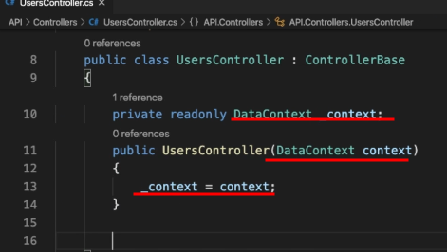

to get access to the database use dependency injection and assign it to property in ctor

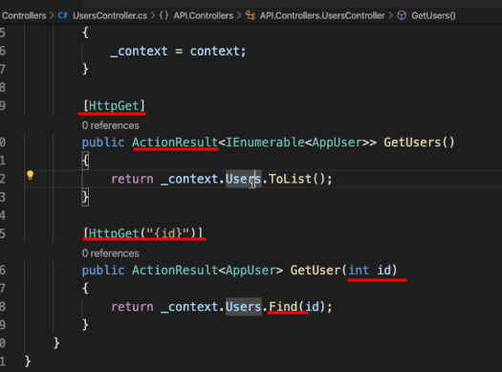

Here attribute HttpGet is applied to the method.

This will be called when we hit the endpoint api/users with get.

Attribute HttpGet(“{id}”) is applied when we hit the end point api/users/1 or any number the end

That number will be the argument to the method.

Find() method is provided by entityFramework.core find the entity with primary key value

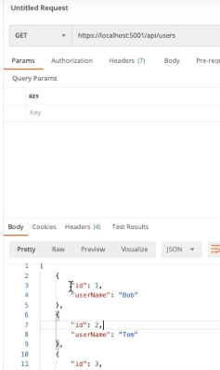

Props in Response which is in json is camel case default convention of apis have and MS follows.

Typically json is in camelCase

Our props in code are title case.

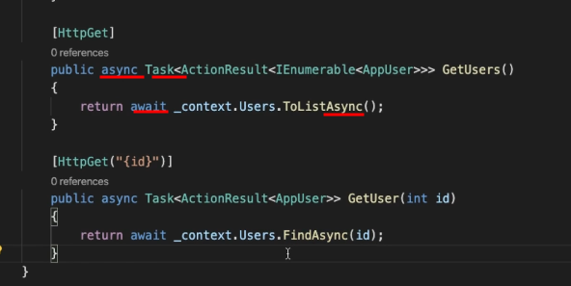

Calls made to database need to asynchronous

To do so use async keyword on functions and will return Task.

And will use await keyword on lines inside the function. Ans also async version of ToList();

So here when a req goes to database it waits , pauses the code then a task goes to database and does the work and comes back then we need to get the result out of the task and we do that by await keyword

Authentication basics

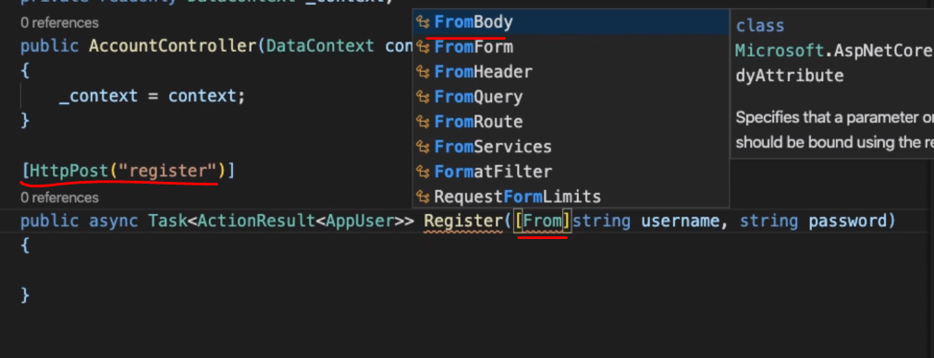

Parameters of HttpPost endpoint is filled by apicontroller attribute.

Or we can tell it from where it can take it ie body or query

DTO – data transfer object is used simply to transfer data and while transferring data we cannot use our domain model as it may have sensitive info or a lot of info which is not required while transferring. We can flatten objects if we want .

Also to convert the parameter in req body.\

Also validation can be performed on dtos while converting req body parameter into dtos.

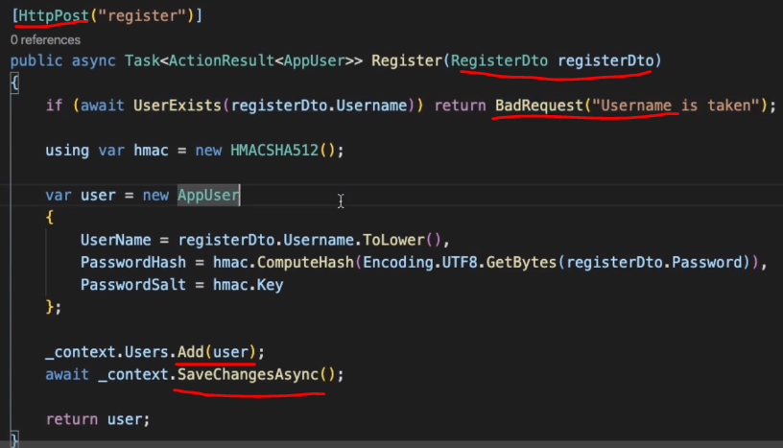

Now here para is regersterDto which has prop similar to req body it will automatically map

Add(user) only track the changes in DB.

SaveChangesAsync() save the changes in DB

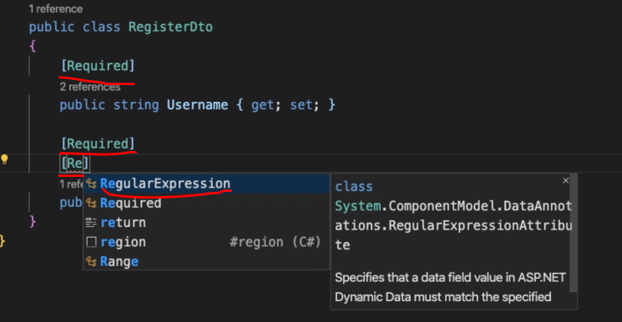

Validations can be done on any level but DTO level validations is preferred.

As apiCOntroller attribute automatically validated the props of parameters(regDTO) of API endpoint.

Login EndPoint –

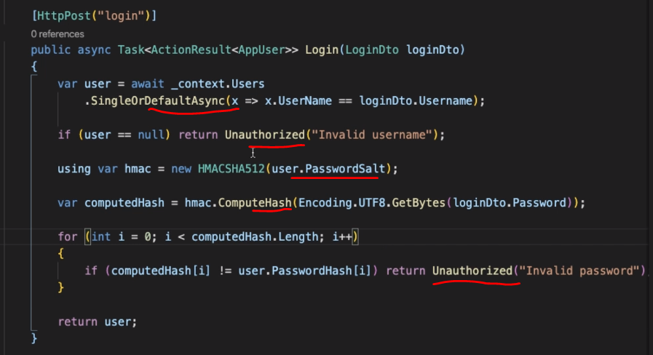

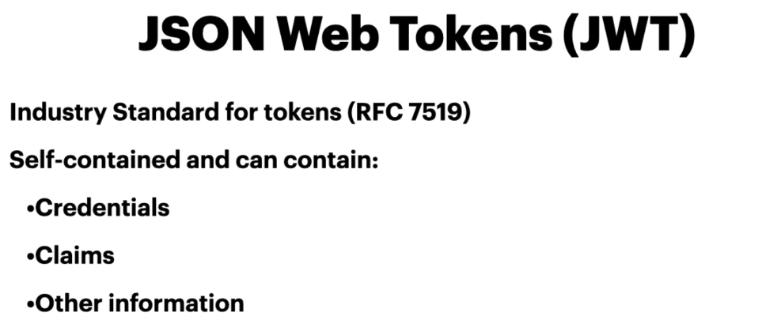

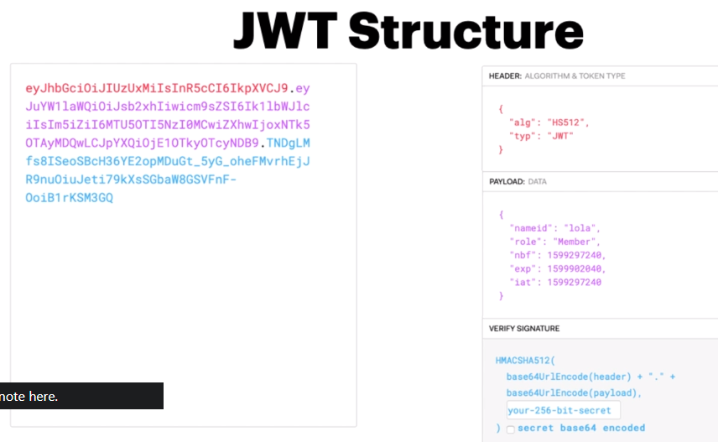

There 3 parts to a JWT first is header which has algorithm used to encrypt the token type of token

2nd part is payload such as claims of user and some time stamps

3rd part is the signature which is encrypted by a key on the server this key never leaves the server.

We can easy decode the header and payload in the token but the signature.

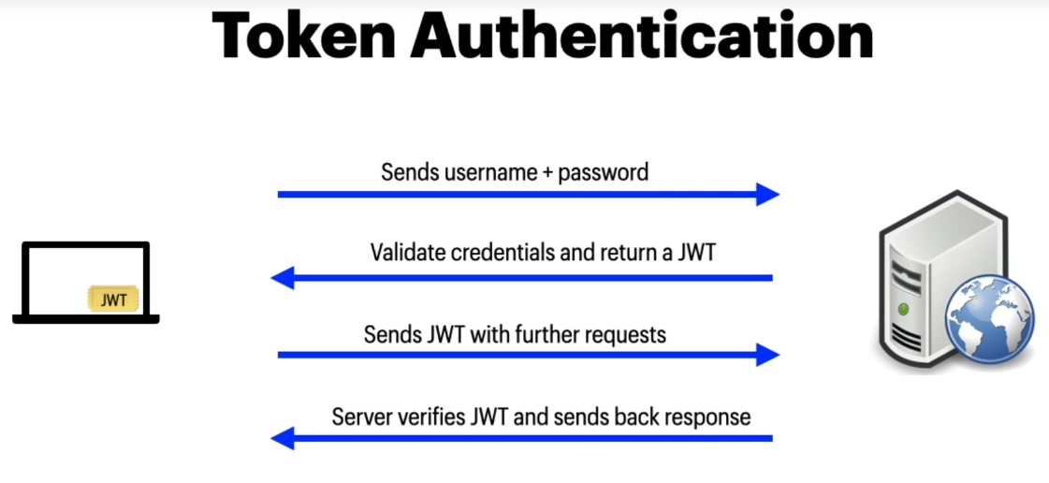

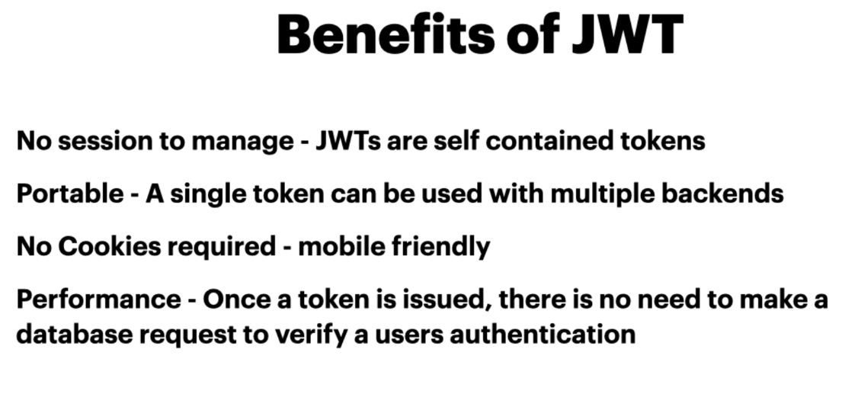

Adding service to the application and defining its scope-

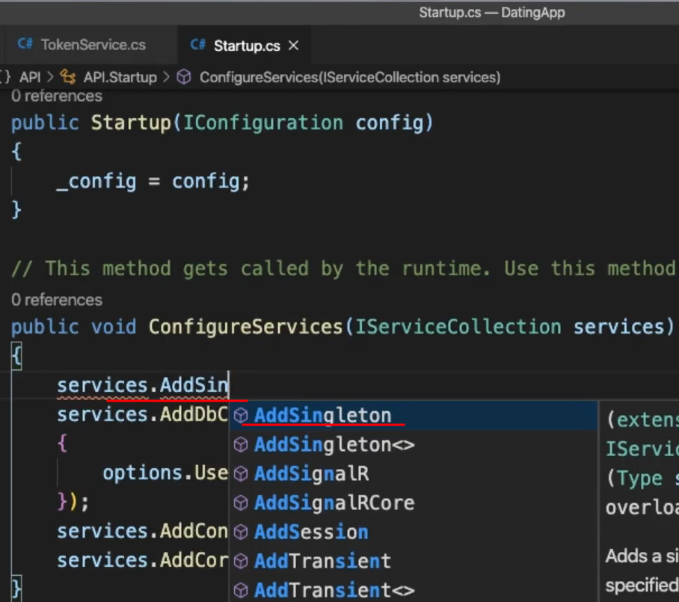

Singletone – it is created only once and it is destroyed as we application is destroyed

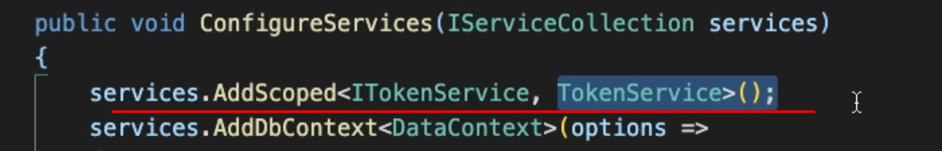­­­­

Scoped – scoped to the lifetime of http req (eg for token service we will be injecting it in a controller hence as req comes in a new instance of the service will be created.) this is most of the time

Transient – created and destroyed as soon as method is finished.

Creating a JWT token –

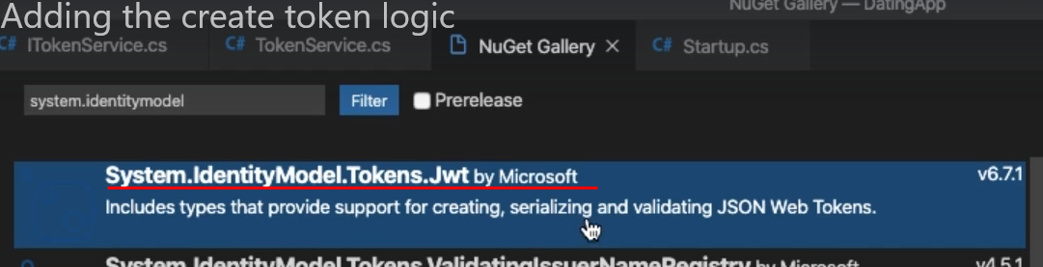

We need to import this package

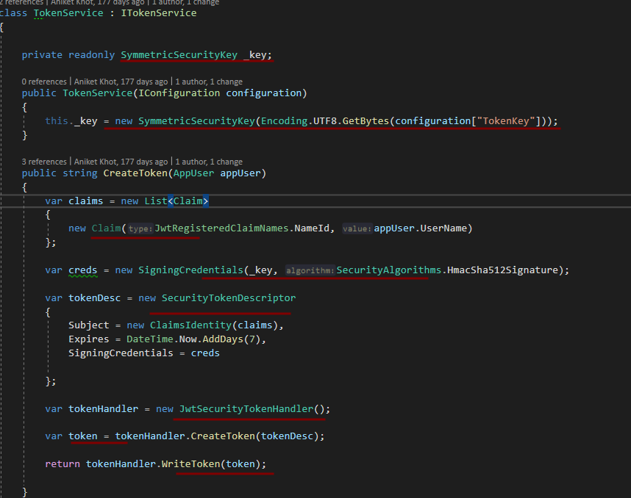

We use a symmetric key which means signing and verifying of token will be done by the same token key present at server. This key never leaves the server.

Then we create the token by adding claims, creds and descriptor and then return the token.

Adding authentication middleware-

We add “Authorize” attribute to protect our end point.

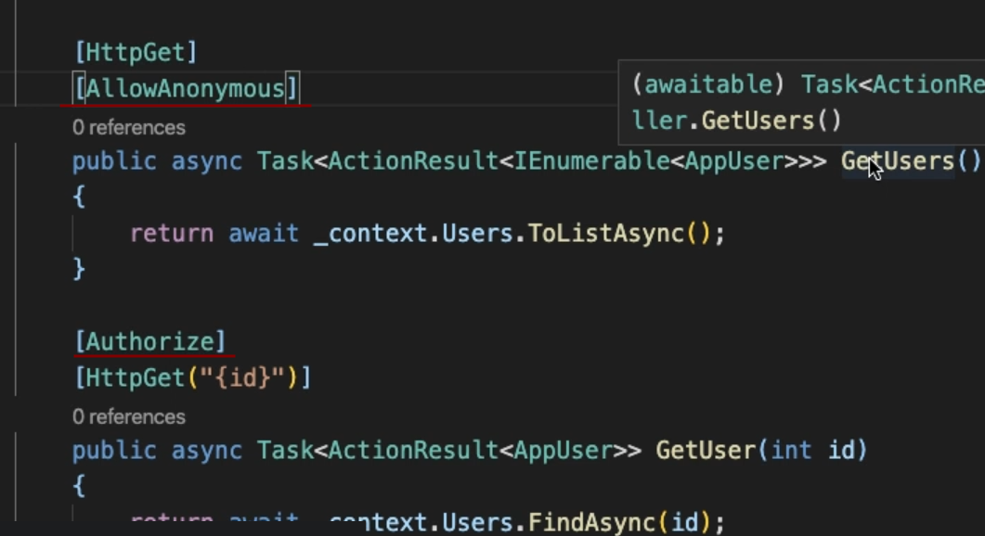

In this case if we send req then end point with attribute Authorize will fail saying

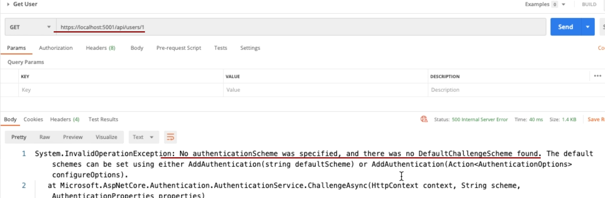

For this we have to put in an authentication middleware in our application to authenticate endpoints with authorize token with JWT token.

we need this package to do add this middleware



First will add a service for authentication. Where authentication scheme will be mentioned and token validation parameter like key.

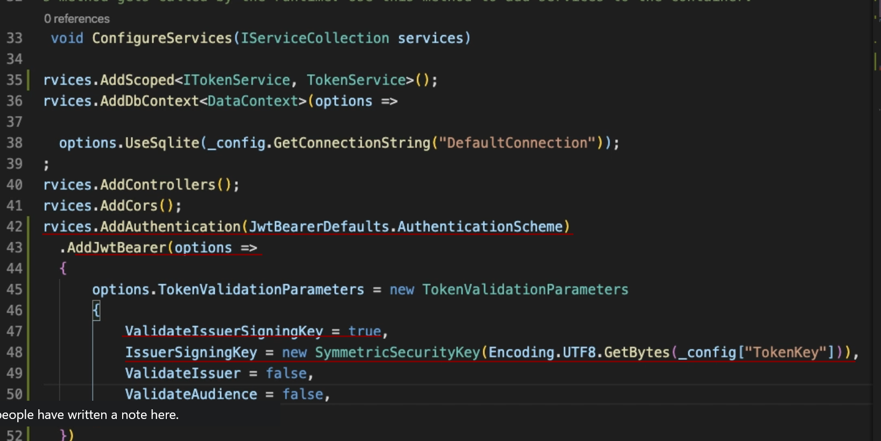

Then will add a middleware

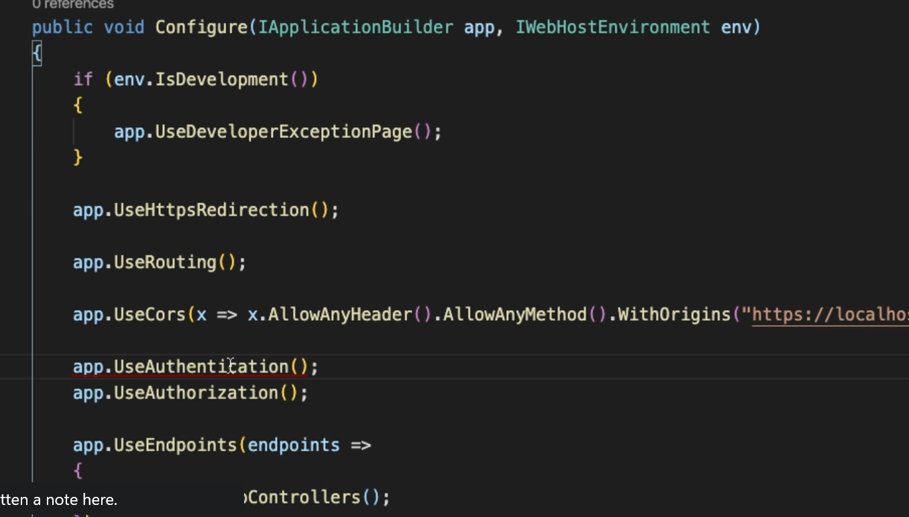

Here Ordering is important

While making a req add a authorization header with value Bearer space and token itself as shown in below image

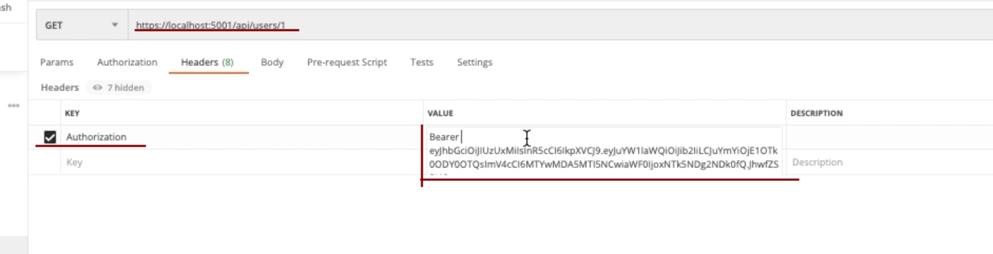

Section 5 Client login and register.

* All angular hence not documented

Section 7 – error handling

Exception handling is done at top level.

That’s the first middleware in configure method.

Exceptions are caught on global level.

Adding middleware –

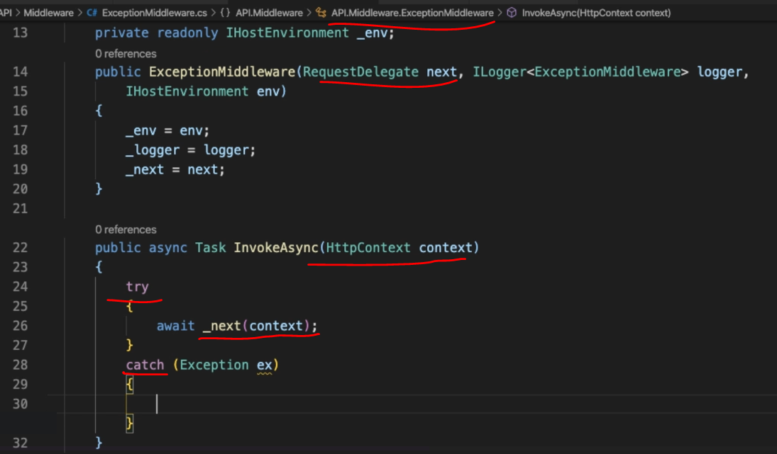

For handling exception we are adding a middleware

First we will need class here it is ExceptionMiddleware

Then in its contructor will need RequestDelegate which we will use in InvokeAsync method to continue to the next middlewares as this middle ware is the topmost.

And as we return the response to client, depending upon response we will navigate the user or show toaster message.

Section 8 : Extending API

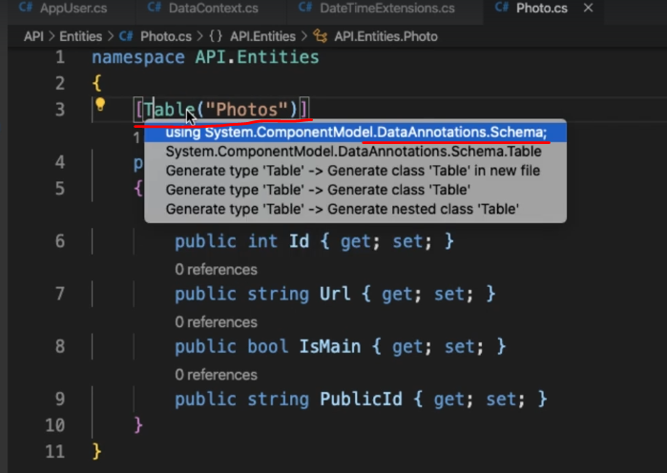

If we want to change the name of a table other than the name of the entity then use Table attribute to set as shown. And bring table from mentioned namespace.

Now we a one to many relation that is a User can have multiple photos.

So when we hit the command

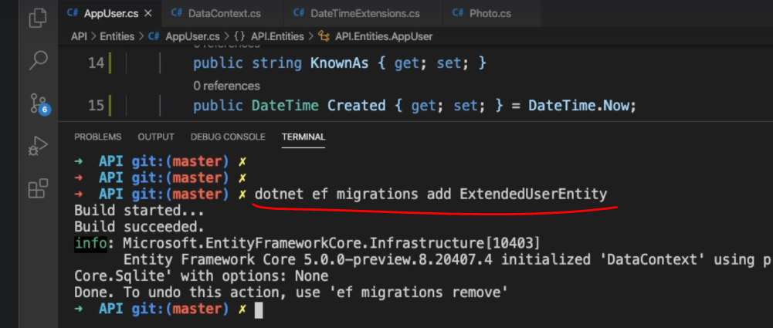

Looking at result in migration file

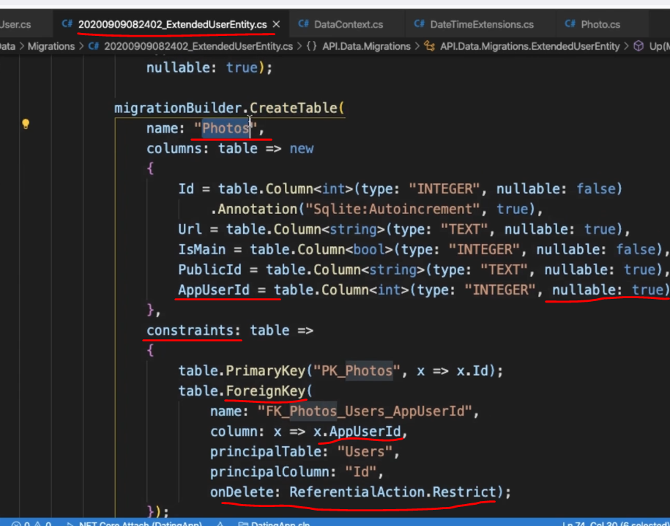

Here we can see the name of table is “Photos” but class name is Photo this is because we had added “Table” attribute to change name of the table

In constraints ef has added a foreign key from Users Table that is AppUserId.

Inside Photo class we don’t have AppUserId still it has added this column,

This is because EF knows that there is relation between photos and AppUser hence it automatically added it

Though this is nice we have this added atomically but having AppUserId as Nullable means a photo may not have a association with user. This is not possible.

Also onDelete behaviour here is ReferentialAction.Restrict which means if we delete a user we don’t want to delete photo. Which is not desired here

To overcome such problem, we have to do Following steps-

First will remove this migrations using “dotnet ef migrations remove”

If we don’t want AppUserId to be nullable and we want cascading effect of deleting user on photos.

Then we have to fully define the relationship between Appuser and photos.

One user with many photos which we already have added and other which we will add now which we define a user inside photos

We do it as follows

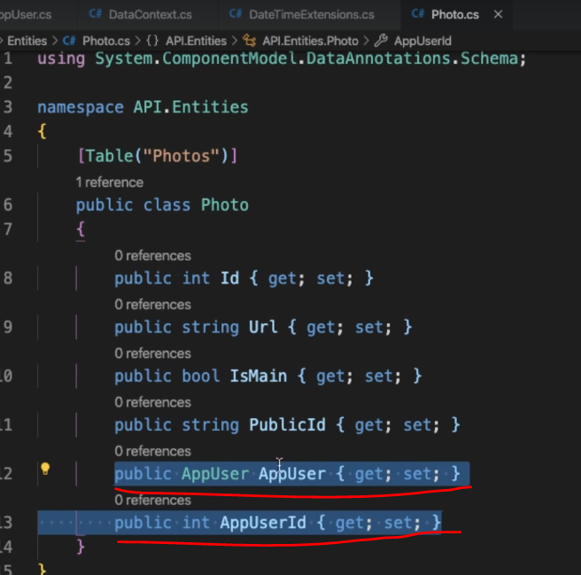

Now if we add migration “dotnet ef migrations add [name of migration]”

What we will see is this which is as desired

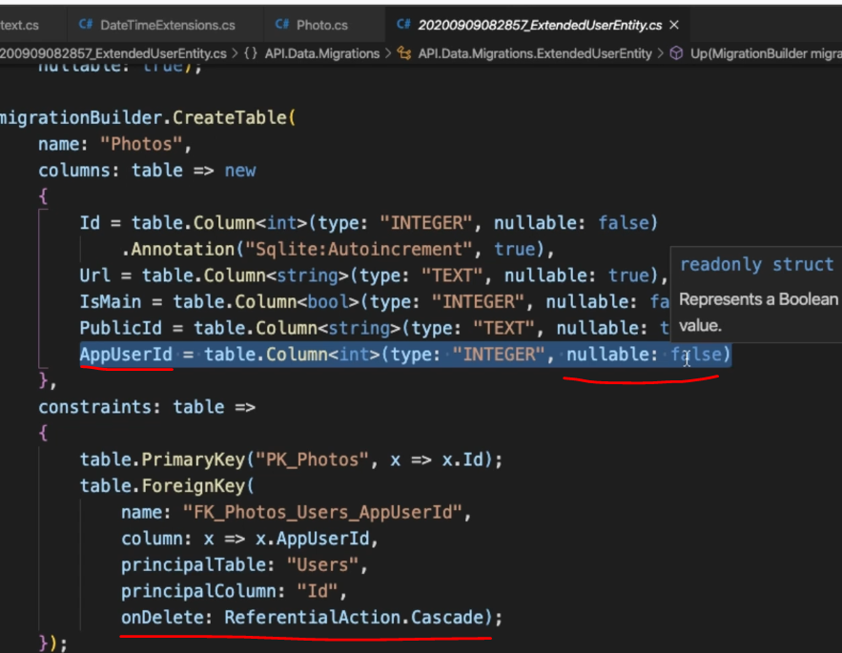

And now if we update the database “dotnet ef database update”

We will see our user table is altered with new columns and a new table photos is added.

**DataSeeding – 89 lecture**

Its just inserting dummy data in database when we are opening our application for the first time.

In main() method we seed the data if database has nothing in it unless nothing is done.

In postman we can use test to do some basic things when we request. Such as saving the bearer token in global variable so that it can be used while making other reqs.

**Repository Pattern-**

Encapsulate the logic

Reduces Duplicate query logic

Promotes Testability

Decouples application from persistence framework

All database query are centralized and not scattered throughout the app.

Allows to change ORM Easily

First will need to create interface corresponding to a entity for eg for user we may create IUserRepository and implement it in a class as UserRepository

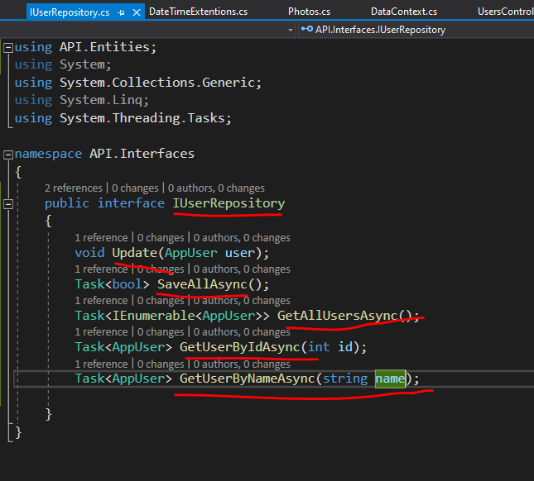

this class will contain the implementation of interface having methods which are related to DBSet of User in database.

Then will add this to ConfigureService() method with scope as “scoped” as we want to initialize this particular repository only when needed.

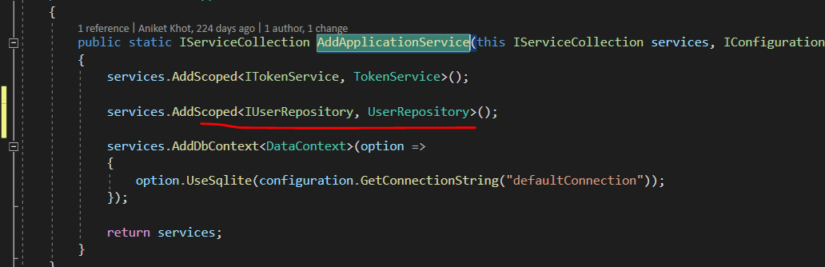

**Gettting Data from database – (non - efficient and efficient way )**

When we try to get users we have photos as null

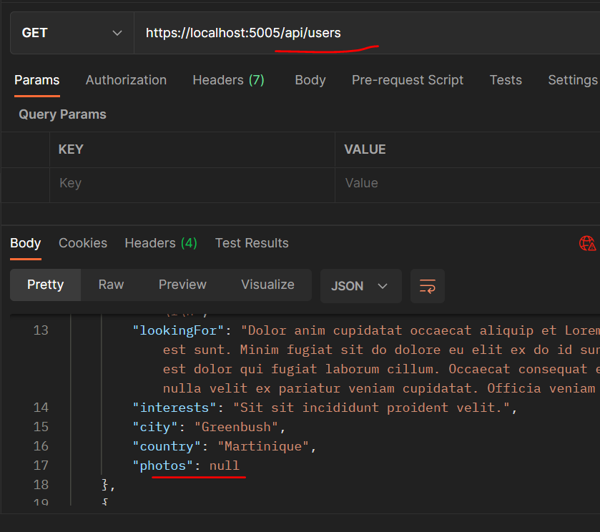

This can be solved by adding include()

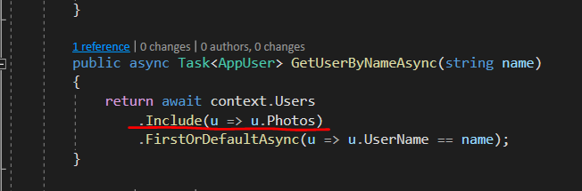

Even with this much fix the problem will not be solved we will have server error

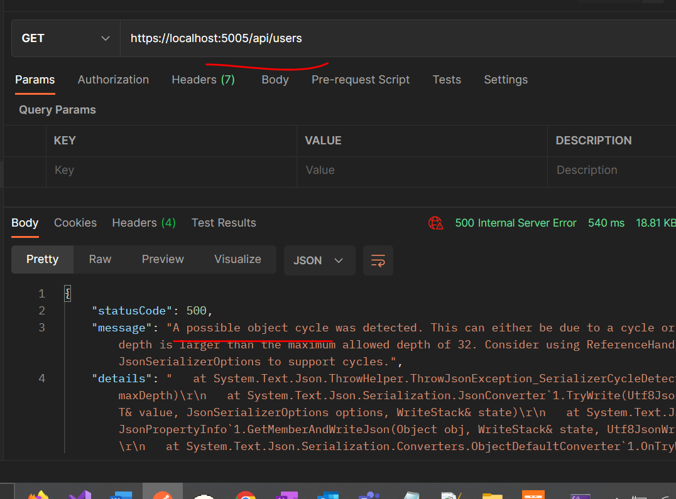

To solve this

Create DTOs for AppUser and Photo (only needed props no need of passwordsalts ans hash)

Include a automapper package 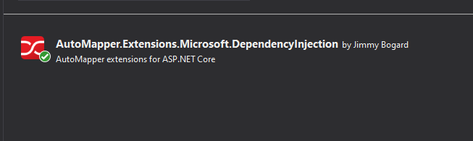

Create a class for automapper extend it from Profile from package we installed.

And create methods inside ctor for mapping porps of classes

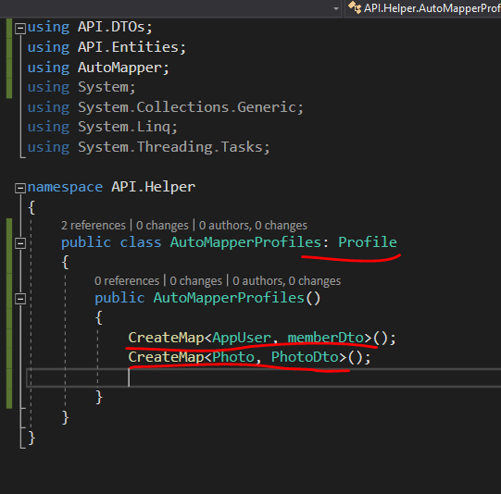

In UserController we will return memberDto

Using automapper Appusers will be mapped to memberDto

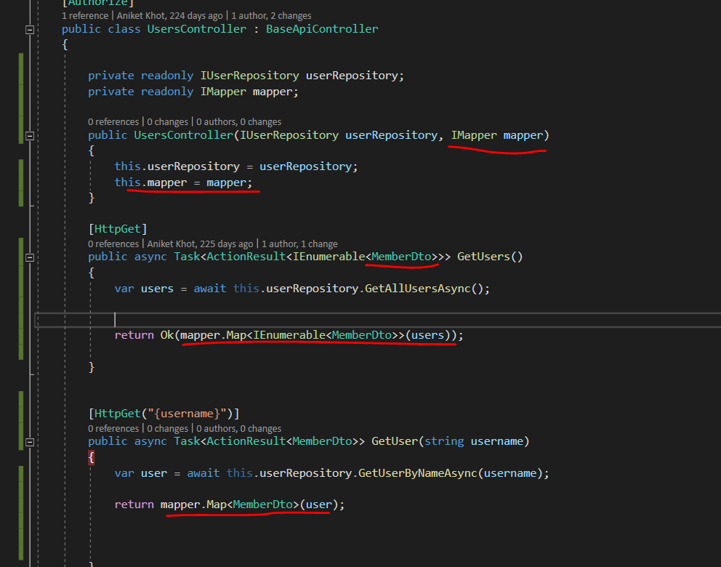

Auto mapper automatically maps the props with same name

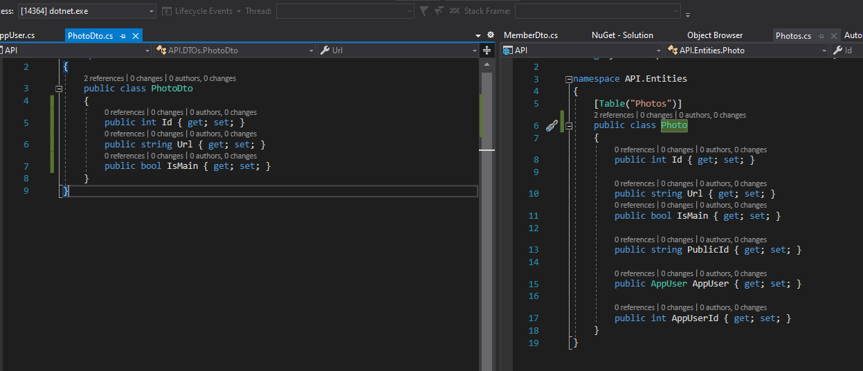

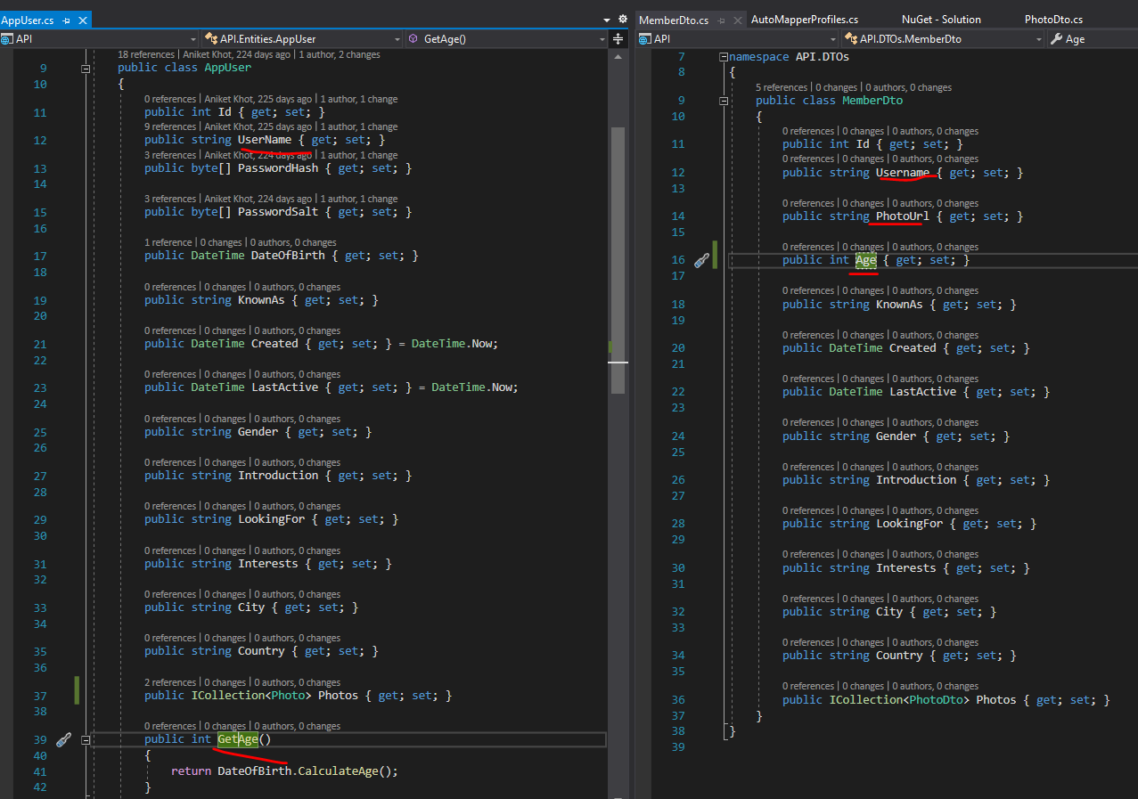

As we have no circular ref in DTOs we get photos properly

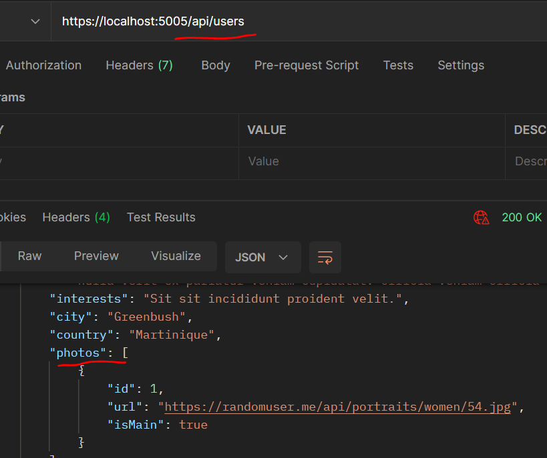

For Age it maps the GetAge() method username have the same spelling but N is upper case that is also mapped

photoURL doesn’t get mapped to do this will need to add some configuration to automapper

We map the property PhotoUrl

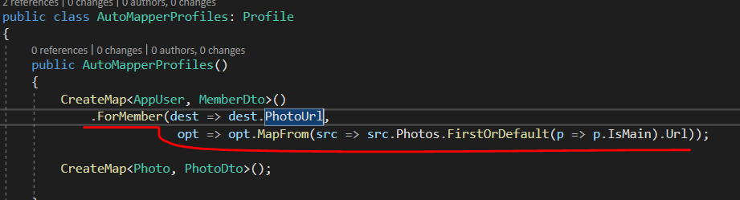

**THE ABOVE SOLUTION TO GET USERS FROM DATABASE MAY BE CORRECT BUT NOT THE EFFICIENT ONE.**

**As we getting entities for DB then mapping it(to memberDto) in a way which is suitable for response.**

**Rather than doing this we can bring things from DB which are needed. Ie will directly bring things as per MemberDto**

**LETS LOOK AT THE EFFICIENT ONE.**

To bring MemberDto Directly will add new methods in repository

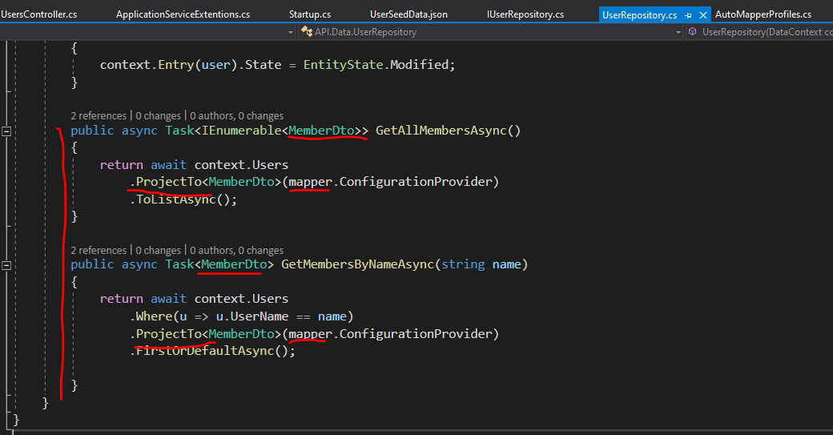

While Bringing things from User DBSet we will only call MemberDto props.

ProjectTo() method from AutoMapper helps us to do so. We just have to pass the configuration(in autoMapperProfiler) of Automapper to this method. Then it will bring things which are needed(MemberDto).

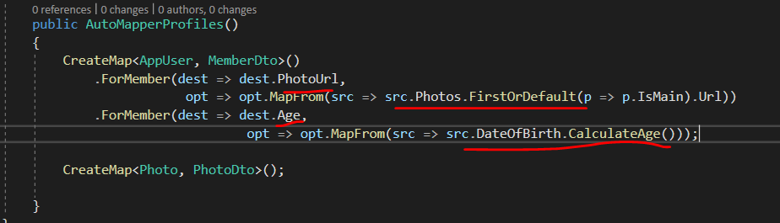

**GetAge(**) method in AppUser Entity for this automapper has to call the whole entity hence this is defeating our main purpose hence do not use the method to get the age, whatever things we want to add or map that will add in mapper configuration(AutoMapperProfiler)

**Include() method not needed** as We can avoid using Eager loading (include) by using SELECT statements (projection) to select just what we need.   When we use select statements EF will automatically include any related entities for properties that we select.   Using AutoMapper ProjectTo will save us from needing to actually write the SELECT statements as this takes care of it for us.

**Section 10 : Update Resources**

**Persisting the changes in API:**

Create a UpdateDto related to the req body and whatever things to update

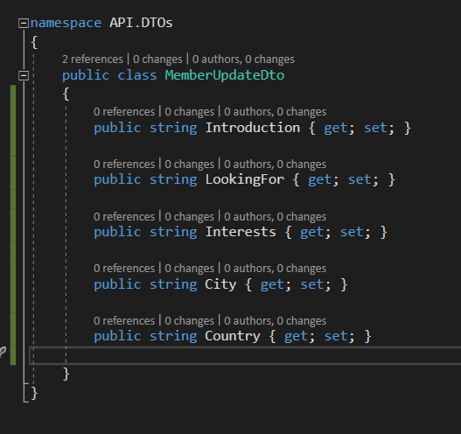

When the req comes to the controller get the User from controller which is a ClaimsPrinciple (this is used to validate the user by API).

From the user get the username , from username get the AppUser from DB

Map the update DTO to Appuser

In auto mapper we have to create another mapper for this purpose

And then flag the entity to update it then save the changes 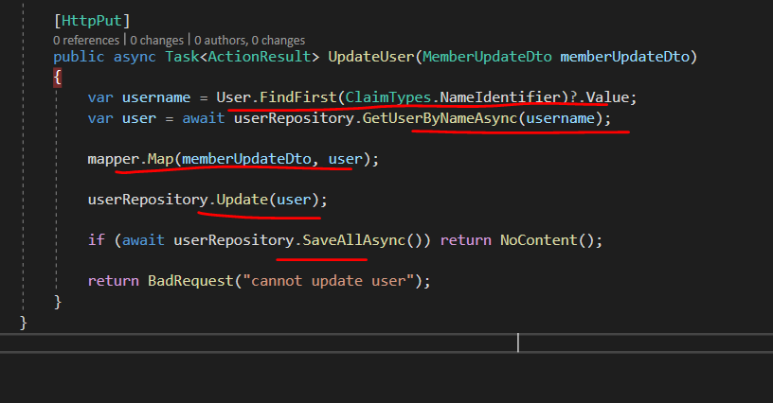

**Section 11 - Adding Photo Upload functionality –**

install the nuget package

set up the configuration in appsettings.json and then strong type it and make it available through adding it to ConfigureServices()

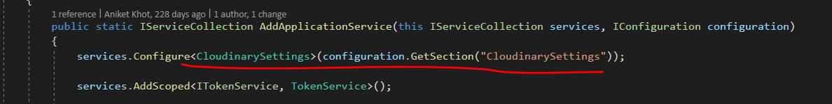

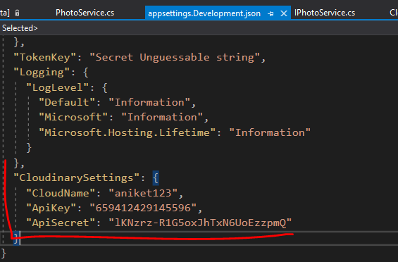

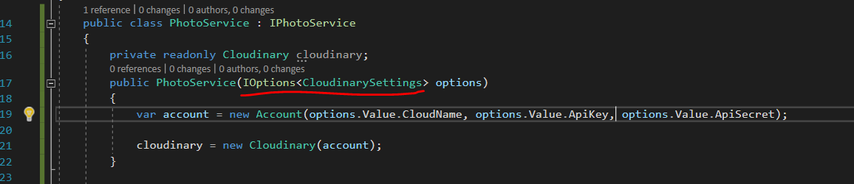

This is how u use the strongly typed configuration using IOptions interface

In Microsoft.Extensions.Options

While accepting file as rest parameter IFormFile is used

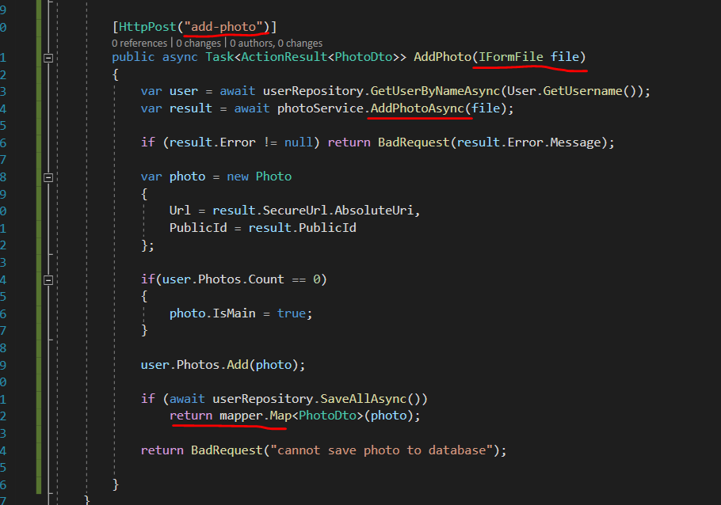

While passing the file as parameter in body select the Formdata and then File

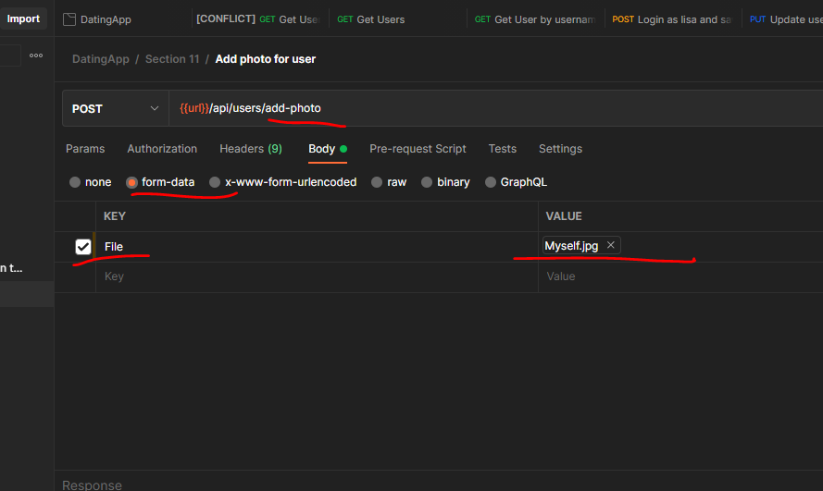

When we create a resource on server we are supposed to send 201 created response along with a location header static where the file is located.

To do So-

Will name a route where the resource is located. In this case the “GetUser”

As that is the only way user can get the saved photos(resource)

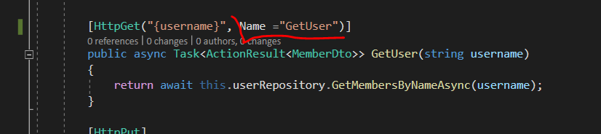

Then use method CreatedAtRoute() mention the route name we gave already then in this case the route requires a username hence 2nd arg is that username and the photoDto.

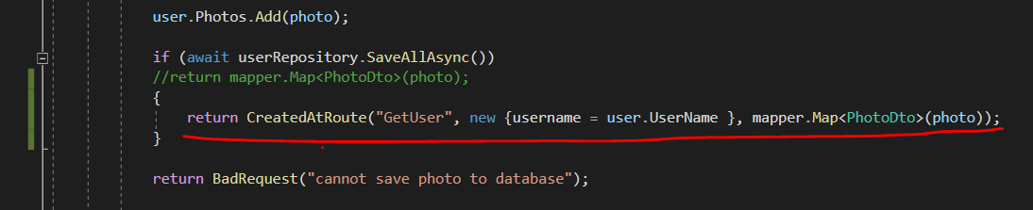

And this will give us in resp 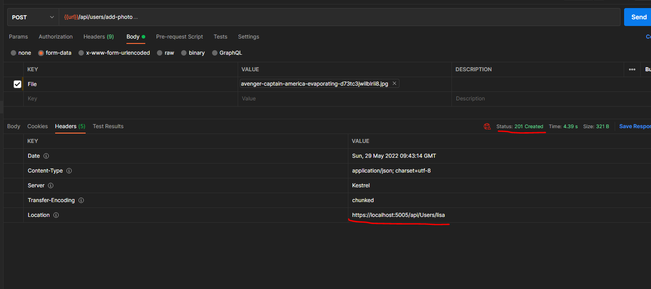

A location header and response as 201 created which is expected.

Setting the photo as main with photoId

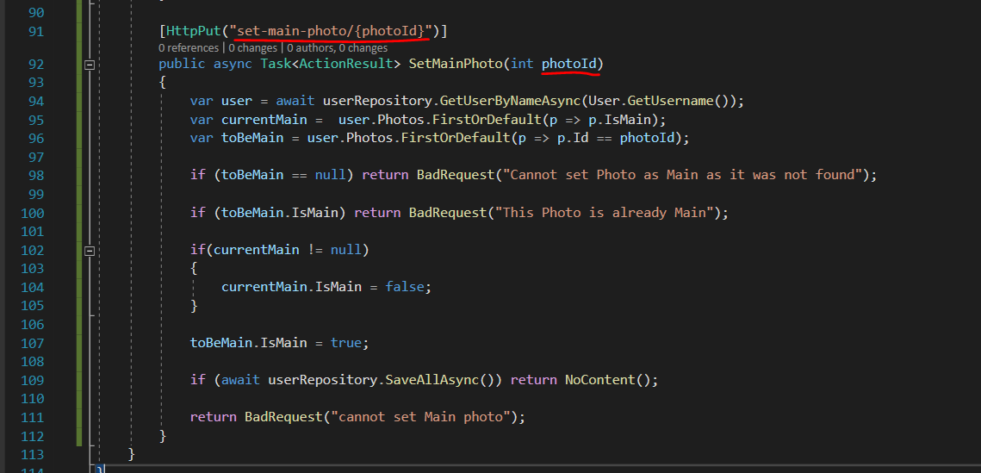

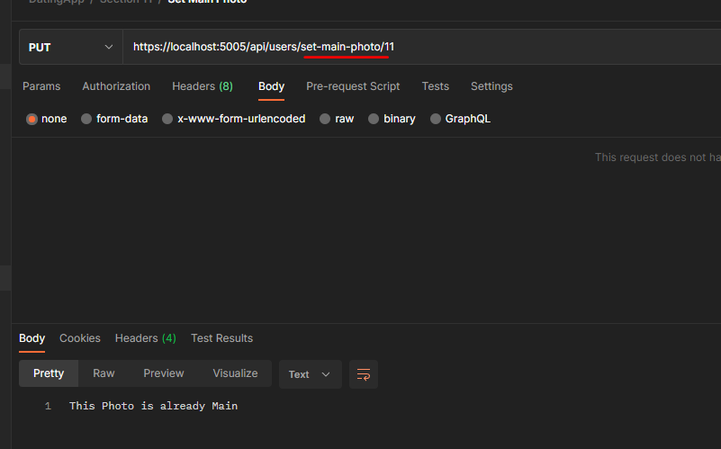

Delete Photo –

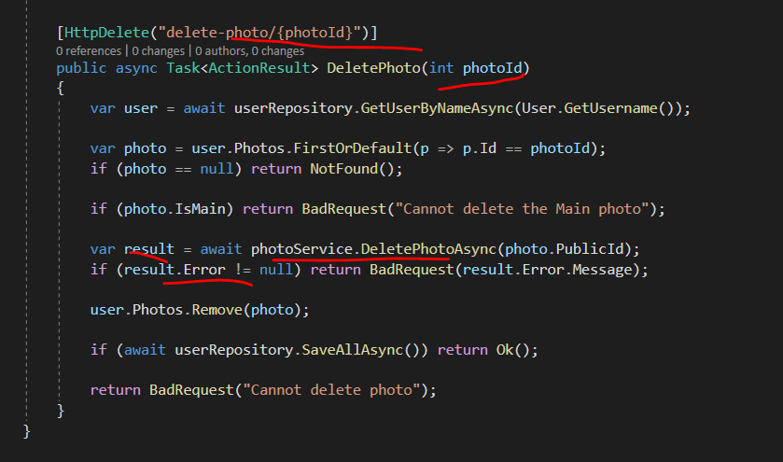

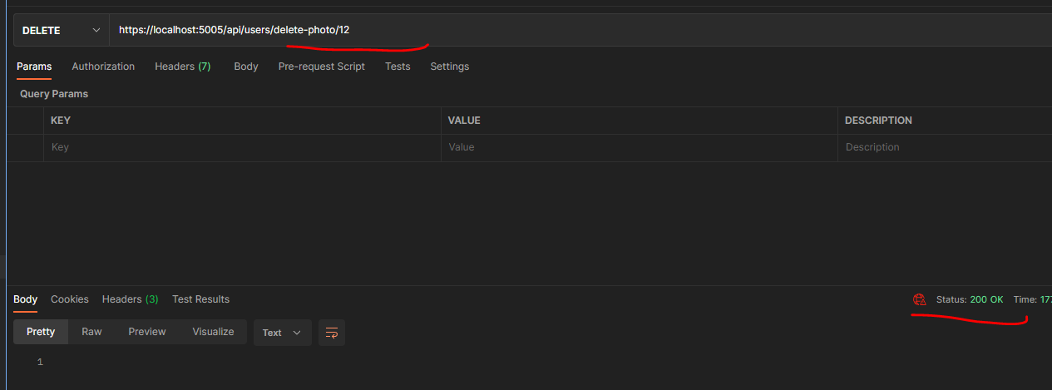

Section 13: Paging, Sorting and Filtering

Pagination-

Every time when we execute a database query we need to specify how many rows we want and what to skip depending query.

this can be done in a reusable fashion, so that we don’t have to do it for every query

basically we will need the current page user wants see ie pageNumber

total count of rows fetched. ie Pagesize

And the rows itself ie items.

These will be props generic class PagedList<T> : List<T>

Depending upon what kind of data we need we will fetch the data from database using this class

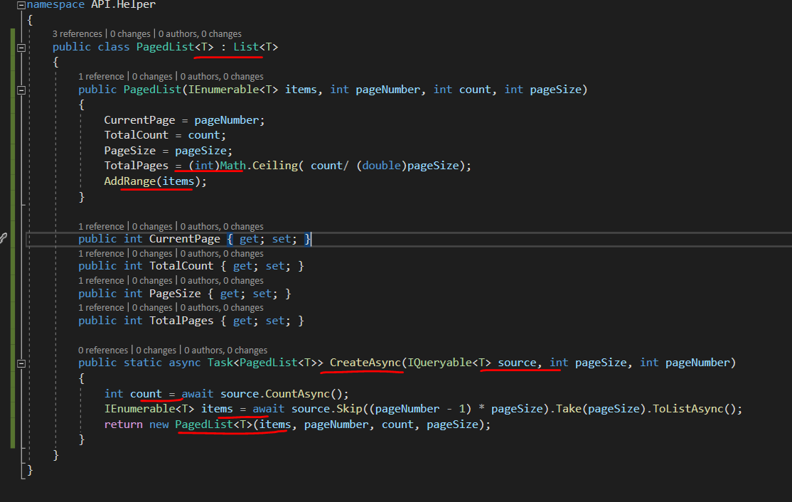

We have a static async method which will be use for creation of the pagedList class.

In case of pagination we have to make 2 database calls one for total count

And other for current page data.

These 2 database calls are done while in this static asyn method.

In case of pagination, when sending response we have to add a header about current pagination info / whats being paged in current req’s response.

For this create a class this info. And write an extension method of HttpResponse to add header .

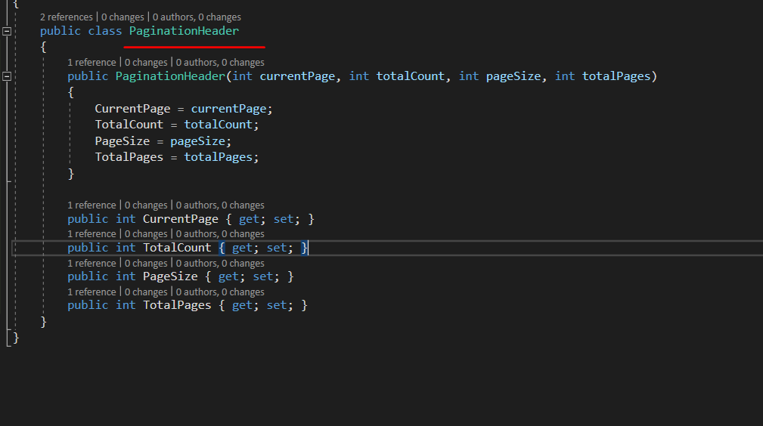

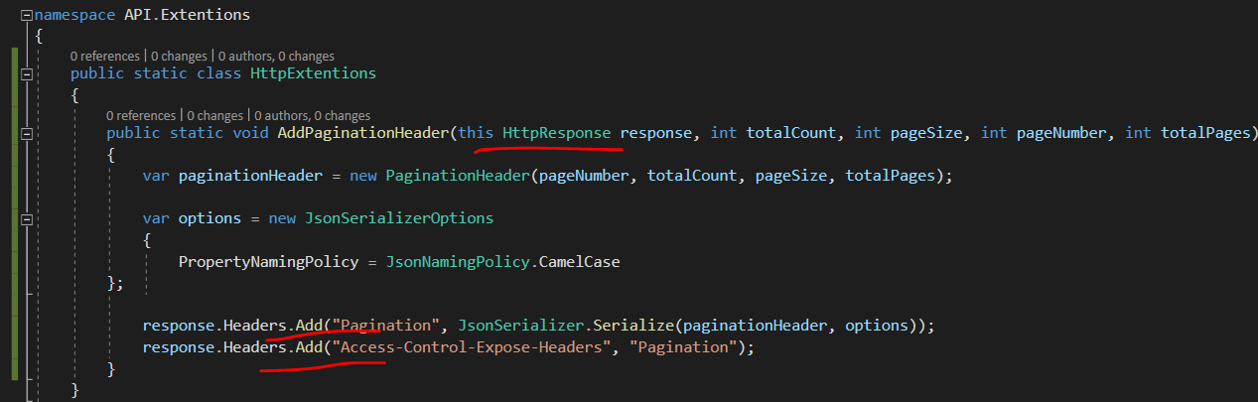

“Access control expose headers” this header is need to be added to make our custom header in available.

When req comes to controller we have to accept some params pageNumber and PageSize.

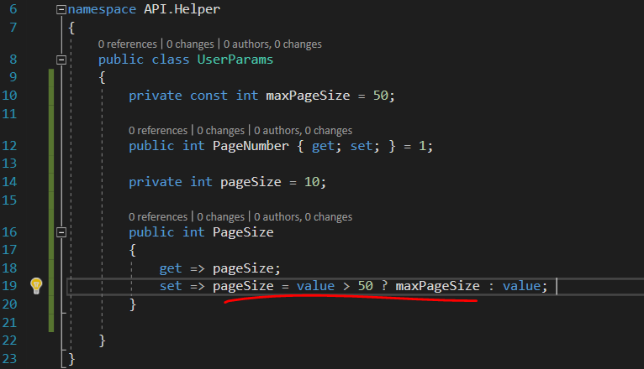

Now in user IUserRepository and its implementation change method

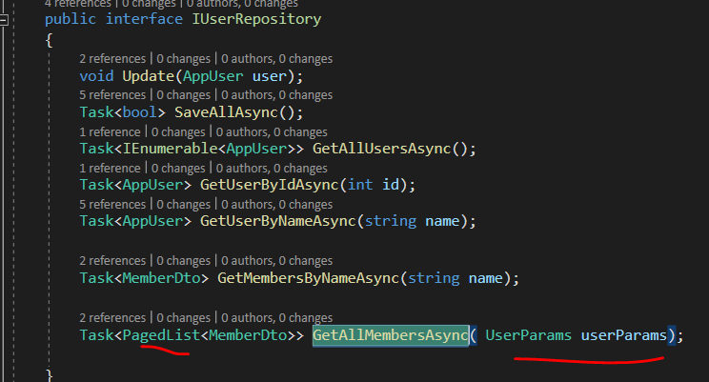

In its implementation we first create a query do not execute it.

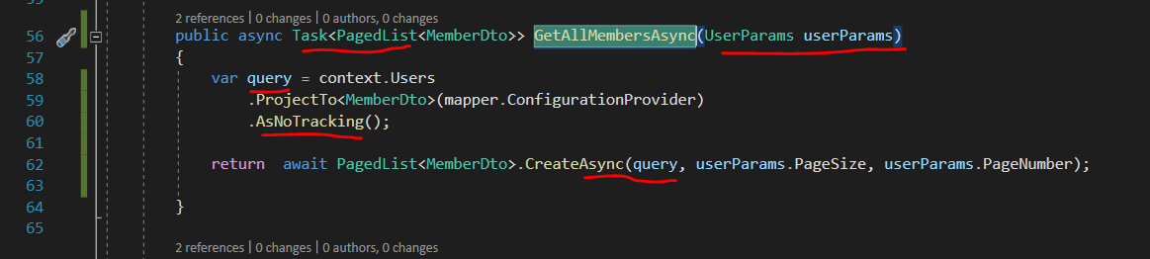

Then this query is passed to pagedlist their it gets executed.

While creating query we say AsNoTracking() meaning EF need not to track this as its only reading it.

We return it to controller.

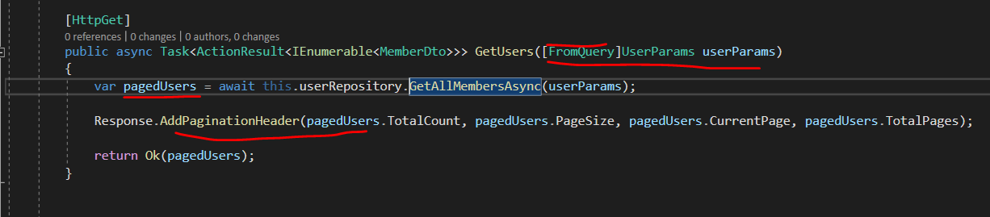

Here we say fromQuery to params as CurrentPage and size is coming from queryParams.

Then we get pagedList of memeberDTO and add header atlast.

We always have access to our request and response in our controllers.

Filtering-

While filtering add params to the userParams then do the appropriate call to DB ie first create the query then execute it.

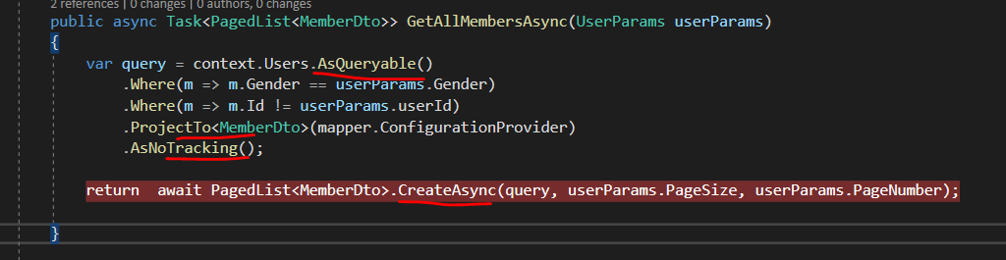

Below is how we can pass query params.

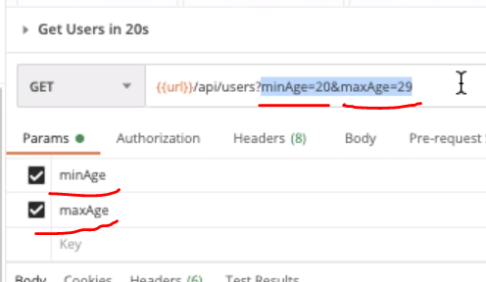

Action Filter-

Changing last active property of user as user does some activity.

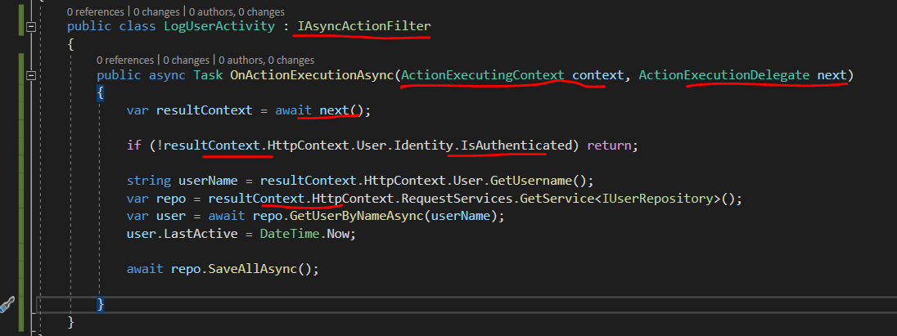

For this what we can use is IAsyncActionFilter it has a method to be implemented called OnActionExecutionAsync() it has 2 para context which has info of current action that the httpcontext and routedata and model state.

2nd para is next. Whats gonna happen next after the action is executed. Once the action is executed( eg user HTTp request - could be saving something) we get the actionExecutedContext then we can perform whatever things we want to like in this case updated last active property.

Next is delegate it returns actionExecutedContext which can be used to get info such as whether user is authenticated etc.

OnActionExecutionAsync() will be executed for every action.

As this class will be a service hence has to be registered in the configureServices() of startup class as Scoped as the scope is for req.

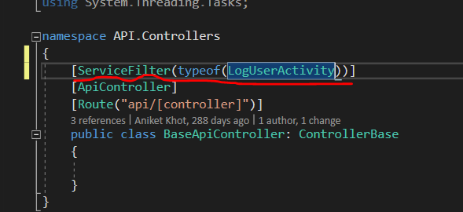

Add above attribute with the given type where the action filter is implemented. As this is in base class meaning this will be applicable to all the controllers and hence to all theactions in those controllers

Many to Many to Relationship (this is for .net5 and from .net6 there is diff way of doing it ..easier)

In our case both source and target entities are same so this might be tricky

But usual example is Book and author

Book can have multiple authors and authors can have multiple books

In our case User can like multiple use Users and User can be liked by multiple Users.

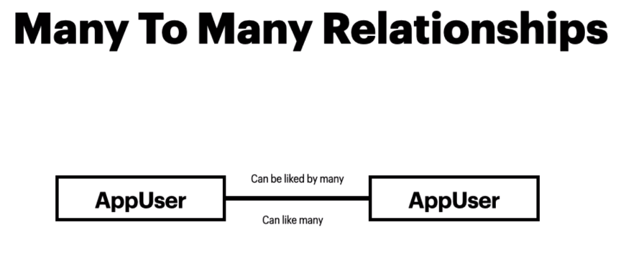

In SS naming is bit different eg - UserLike(Like) , LikedUserId(TargetUserId) , LikedUser(TargetUser)

For this type of relation we use a joining table in this case UserLike(Like)

Which has 2 columns SourceUserId and LikedUserId(TargetUserId)

Entity has source and target entities as well but in table only Ids columns are stored, this is how to works.

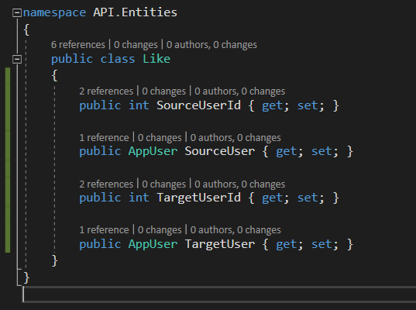

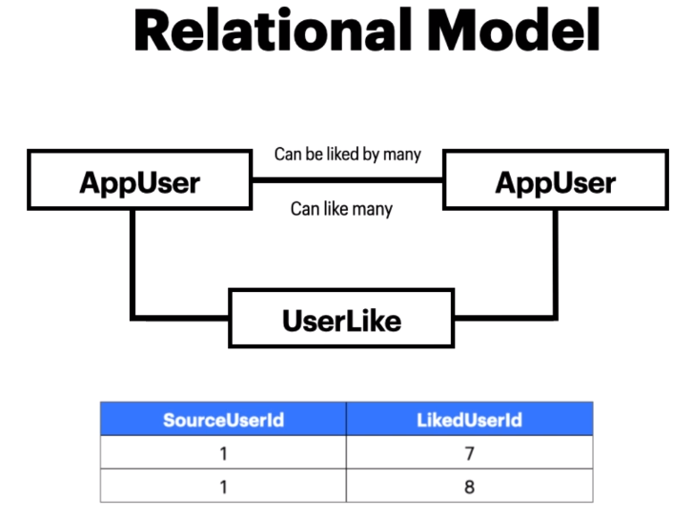

Using fluent API we Configure the entity relationship

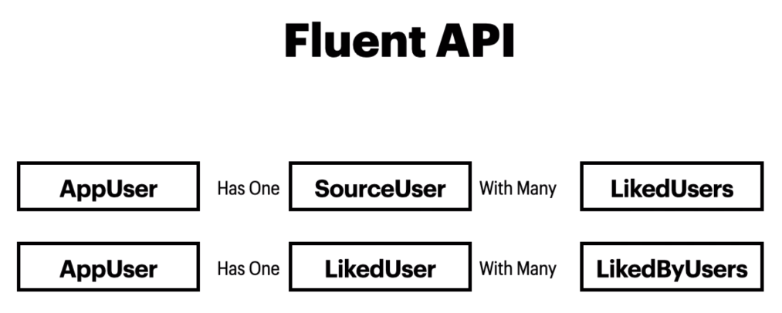

First we add dataset of likes

In DataSet class override method OnModelCreating.

In this method we call base classes same mthod.(if not may cause problems)

modelBuilder has method entity which we will be used to configure the entity

add primary key using hasKey() this can be done in the entity itself but we can do it here as well

then one way relation of many to many ie one source user has many liked users

other way is a user which is liked(targetUser) has liked by many other users.

Then the foreignkey and delete behaviour.

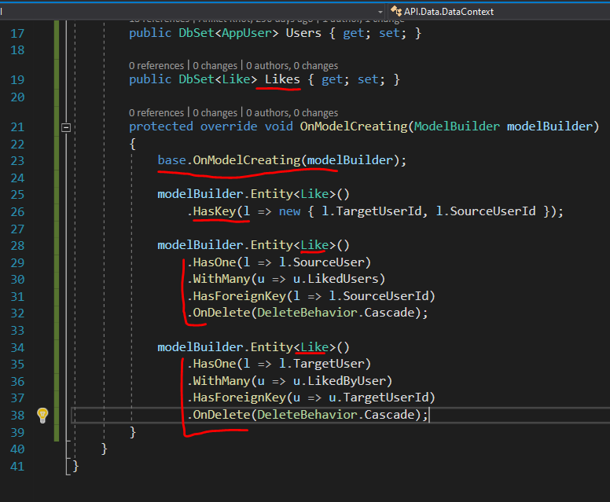

This whole set up for setting up many to many relation is required as it is. And then entity framework takes care of rest.

And add the migration and update the database